The Small Thin Quiz of the Year 2019
It’s a year of the Brexit-that-never was, election fever, female empowerment, TV and movie finales, environmental protests…and a Star Wars finale to wrap the year up. So, what better way to reminisce than with another Small Thin Quiz of the Year?
Feel free to share with friends & family – all I ask is a hot chocolate for each share
And without further ado, here we go…!
January
- What could customers at Greggs get their teeth into this month, causing Piers Morgan to go on a Twitter rampage and spit it out on live TV?
- Which country became the first to land a spacecraft on the far side of the moon this month?
- What became the most liked post on Instagram ever this month, beating an image of Kylie Jenner?
- Theresa May lost a vote on Brexit on the 16th January, but what unfortunate record did this vote break?
February
- Why was all horse-racing cancelled for 6 days this month?
- Who or what’s last message was: “My batteries are low and it’s getting dark?”
- Chelsea’s Kepa Arrizabalaga caused an “incident” which Maurizio Sarri later referred to as “a misunderstanding”. What did – or didn’t – he do?

March
- Which European country elected its first female president this month?

April
- What “first” did Dr Katie Bouman and her team achieve this month?
- What famous landmark caught fire this month?
- What did Japanese Emperor Akihito do this month, “the first for over 200 years?

May
- The Duke and Duchess of Sussex welcomed their new son into the world on the 6th May, who instantly became seventh in line to the British throne. What’s his name?
- Both Spurs and Liverpool had epic Champions League semi-final games, both having lost their first leg and overturning deficits to end up both going through to the final.
Who scored more though – Liverpool or Spurs?

- The finale of Game of Thrones was aired this month. Who became the ruler of Westeros?
- Which famous broadcaster naturally decided to get into producing trance music this month?

June
- The Annual Take That question.
Take That’s latest tour, Greatest Hits Live, finished this month. What was the other name for their tour, named after their latest compilation album?

- Which team won the Women’s World Cup in football this month, for a record fourth time?
July
- Avengers: Endgame became the world’s highest grossing film this month, crossing $2.7902bn (£2.23bn) at the box office. What did it knock into second place?
- This month Boris Johnson became the new leader of the Conservative Party and therefore Prime Minister. Also this month the Liberal Democrats also elected their new leader, who led the party – well until December anyway. Who was it?
August
- Why did the people of Whaley Bridge feel like they were damned this month?
- Which football club became the first to be expelled from the EFL since 1992?
September
- “This Court has … concluded that the Prime Minister's advice to Her Majesty was unlawful, void and of no effect.” So ruled Lady Hale, as part of a unanimous verdict from the Supreme Court. What specifically was ruled void and effectively quashed this month?

- Channel 4’s reality TV series “The Circle” returned to screens this month, where contestants live in separate flats and can only communicate via a social network called The Circle. Which celebrity joined the show, pretending to be a 27 year old uni drop-out called Judy?

October
- "It's... Rebekah Vardy's account."
Who posted this dramatic revelation on their Instagram account, accusing them of leaking stories to The Sun newspaper?

- Why did Steps singer Ian “H” Watkins’ entry into Dancing on Ice make the news this month?

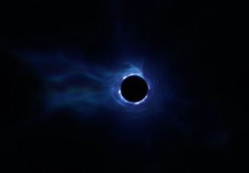
- Which computer game did a Black Hole suddenly appear, swallowing up the map and all the players, to mark the end of the current “season”?
- The London Eye got itself into a spin this month, doing something it’s not done in it’s near 20-year history. What did it do?
For a bonus point, why?
- On Friday 25th October, what rock-and-roll activity did tourists do for the last time?

November
- Why did Pizza Express in Woking suddenly become an alibi fit for a prince?

- What did Channel 4 replace Boris Johnson & Nigel Farage with, when they both failed to appear at the “first ever” Climate Change Leaders Debate?
- On the subject of being empty-chaired, who said the following, after Boris Johnson became the only major party leader to not attend an interview with them:
“…The prime minister of our nation will, at times, have to stand up to President Trump, President Putin, President Xi of China. So it was surely not expecting too much that he spend half an hour standing up to me.”

December
It was a month for Girl Power this month!
- Sanna Marin became the world’s youngest ……. this month at the age of 34. What is she the world’s youngest?

- And Fallon Sherrock became the first woman to win which sporting event?

And finally…
- Who was announced as Time Magazine’s Person of the Year?

Total score: / 35

Answers!
- Link to Quick Answers – without explanations and links, to use when quickly marking other’s sheets etc.
January
- What could customers at Greggs get their teeth into this month, causing Piers Morgan to go on a Twitter rampage and spit it out on live TV?
A meat-free sausage roll.
https://www.independent.co.uk/life-style/piers-morgan-greggs-vegan-sausage-roll-good-morning-britain-snowflakes-a8716071.html
https://www.standard.co.uk/news/uk/greggs-vegan-sausage-rolls-londoners-split-on-insanely-popular-pastry-as-some-stores-in-capital-sell-a4029871.html
- Which country became the first to land a spacecraft on the far side of the moon this month?
China, with the Chang’e-4 probe.
https://www.bbc.co.uk/news/science-environment-46724727
- What became the most liked post on Instagram ever this month, beating an image of Kylie Jenner?
An egg. Just an egg.
https://www.theguardian.com/technology/shortcuts/2019/jan/14/kylie-jenner-the-egg-instagram-likes
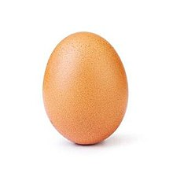
- Theresa May lost a vote on Brexit on the 16th January, but what unfortunate record did this vote break?
Biggest government defeat in the House of Commons, losing by 230 votes.
https://www.independent.co.uk/news/uk/politics/brexit-vote-theresa-may-defeat-mps-history-biggest-ever-loss-commons-a8729791.html
February
- Why was all horse-racing cancelled for 6 days this month?
Equine flu
https://www.bbc.co.uk/sport/horse-racing/47171180
- Who or what’s last message was: “My batteries are low and it’s getting dark?”
The Opportunity rover on Mars.
(Mars rover / Mars probe will all count for the point; “space probe” or similar won’t count).
https://inews.co.uk/news/science/mars-rover-opportunity-nasa-dies-15-years/
- Chelsea’s Kepa Arrizabalaga caused an “incident” which Maurizio Sarri later referred to as “a misunderstanding”. What did – or didn’t – he do?
Refused to be substituted before penalties against Manchester City. They ended up losing.
https://www.bbc.co.uk/sport/football/47352319

March
- Which European country elected its first female president this month?
Slovakia. Zuzana Čaputová showed “you can win without attacking your opponents”, after fighting a positive campaign based on progressive values and political reform.
https://www.theguardian.com/world/2019/mar/31/slovakia-elects-zuzana-caputova-first-female-president

April
- What “first” did Dr Katie Bouman and her team achieve this month?
The first photo of a black hole.
https://www.bbc.co.uk/news/science-environment-47873592
https://www.bbc.co.uk/news/science-environment-47891902
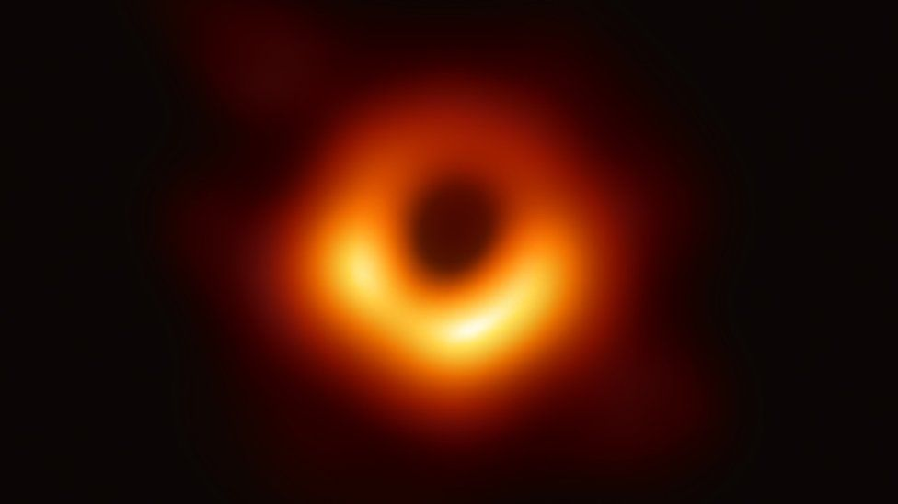
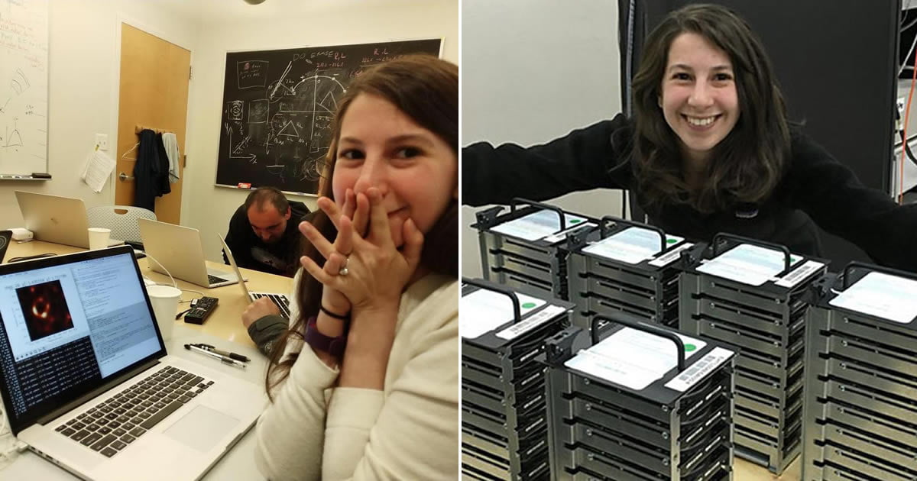

- What famous landmark caught fire this month?
Notre Dame in Paris.
https://www.bbc.co.uk/news/world-europe-47941794
https://www.bbc.co.uk/news/world-europe-47943705
- What did Japanese Emperor Akihito do this month, “the first for over 200 years?
He abdicated, after saying he felt unable to fulfil his role because of his age and declining health.
https://www.bbc.co.uk/news/world-asia-48020703
May
- The Duke and Duchess of Sussex welcomed their new son into the world on the 6th May, who instantly became seventh in line to the British throne. What’s his name?
Archie Harrison Mountbatten-Windsor. “Archie” is enough to score the point
https://www.bbc.co.uk/news/uk-48201625

- Both Spurs and Liverpool had epic Champions League semi-final games, both having lost their first leg and overturning deficits to end up both going through to the final.
Who scored more though – Liverpool or Spurs?
Liverpool, who overturned a 3-0 defeat to Barcelona to win 4-3 on aggregate. Spurs overcame a 1-0 loss to Ajax by winning 3-3 on aggregate based on away goals.
https://www.bbc.co.uk/sport/football/48179167
https://www.bbc.co.uk/sport/football/48192369
- The finale of Game of Thrones was aired this month. Who became the ruler of Westeros?
Bran Stark, the Three-Eyes Raven, now to be known as Bran the Broken.
https://news.sky.com/story/game-of-thrones-fans-rave-over-brilliant-series-finale-spoilers-within-11725102
http://www.bbc.com/culture/story/20190520-how-good-is-the-game-of-thrones-finale
- Which famous broadcaster naturally decided to get into producing trance music this month?
Sir David Attenborough, who was seeking a DJ to remix a field recording he made in Bali 70 years ago. He's asking them to turn the three-minute recording of sacred gamelan music into a club-worthy Ibiza anthem.
https://www.bbc.co.uk/news/entertainment-arts-48198945
June
- The Annual Take That question.
Take That’s latest tour, Greatest Hits Live, finished this month. What was the other name for their tour, named after their latest compilation album.
Odyssey Live.
https://en.wikipedia.org/wiki/Greatest_Hits_Live_(Take_That)
- Which team won the Women’s World Cup in football this month, for a record fourth time?
The USA, winning 2-0 to the Netherlands.
https://www.bbc.co.uk/sport/football/48897032
July
- Avengers: Endgame became the world’s highest grossing film this month, crossing $2.7902bn (£2.23bn) at the box office. What did it knock into second place?
Avatar.
https://www.bbc.co.uk/news/entertainment-arts-49069432
- This month Boris Johnson became the new leader of the Conservative Party and therefore Prime Minister. Also this month the Liberal Democrats also elected their new leader, who led the party – well until December anyway. Who was it?
Jo Swinson, the party’s first female leader.
https://www.bbc.co.uk/news/uk-politics-49076118
August
- Why did the people of Whaley Bridge feel like they were damned this month?
The dam above their village cracked, leading to an evacuation while it was patched.
https://www.bbc.co.uk/news/uk-england-derbyshire-49213042
https://inews.co.uk/news/whaley-bridge-dam-collapse-evacuation-derbyshire-toddbrook-reservoir-flooding-burst-latest-news/
- Which football club became the first to be expelled from the EFL since 1992?
Bury.
http://www.bbc.co.uk/sport/football/49451896
September
- “This Court has … concluded that the Prime Minister's advice to Her Majesty was unlawful, void and of no effect.” So ruled Lady Hale, as part of a unanimous verdict from the Supreme Court. What specifically was ruled void and effectively quashed this month?

The prorogation of Parliament.
https://www.bbc.co.uk/news/uk-politics-49810261
- Channel 4’s reality TV series “The Circle” returned to screens this month, where contestants live in separate flats and can only communicate via a social network called The Circle. Which celebrity joined the show, pretending to be a 27 year old uni drop-out called Judy?
Richard Madeley.
https://metro.co.uk/2019/09/25/how-long-is-richard-madeley-on-the-circle-for-and-can-he-win-10807186/
October
- "It's... Rebekah Vardy's account."
Who posted this dramatic revelation on their Instagram account, accusing them of leaking stories to The Sun newspaper?
Colleen Rooney.
https://www.bbc.co.uk/news/newsbeat-49985658

- Why did Steps singer Ian “H” Watkins’ entry into Dancing on Ice make the news this month?
He will be partnered with professional skater Matt Evers, in what’s billed as the first same-sex dancing couple on a TV show. Strictly later had the first same-sex dance in November, but this was with two professional dancers, not a contestant.
https://www.bbc.co.uk/news/entertainment-arts-49984487
https://www.bbc.co.uk/news/entertainment-arts-50287263
- Which computer game did a Black Hole suddenly appear, swallowing up the map and all the players, to mark the end of the current “season”?
Fortnite.
https://www.bbc.co.uk/news/newsbeat-50038597
- The London Eye got itself into a spin this month, doing something it’s not done in it’s near 20-year history. What did it do?
For a bonus point, why?
It spun backwards for an hour, to mark the end of British Summer Time.
https://edition.cnn.com/travel/article/london-eye-rotating-backwards-intl-scli-gbr/index.html
- On Friday 25th October, what rock-and-roll activity did tourists do for the last time?
Climb Uluru, otherwise known as Ayres Rock. It’s now permanently off-limits; Uluru is sacred to its indigenous custodians, the Anangu people, who have long implored tourists not to climb.
https://www.washingtonpost.com/world/asia_pacific/the-last-climb-up-australias-majestic-uluru/2019/10/25/8f87ab7a-f6a4-11e9-b2d2-1f37c9d82dbb_story.html
November
- Why did Pizza Express in Woking suddenly become an alibi fit for a Prince?
Prince Andrew denied having any sexual contact with an American woman, who says she was forced to have sex with him aged 17, in an interview with BBC’s Newsnight. He claimed he was at Pizza Express in Woking on the day of the alleged encounter.
https://www.bbc.co.uk/news/uk-50446065
- What did Channel 4 replace Boris Johnson & Nigel Farage with, when they both failed to appear at the “first ever” Climate Change Leaders Debate?
A melting block of ice.
https://www.bbc.co.uk/news/election-2019-50596192
https://www.theguardian.com/politics/2019/nov/28/ice-sculpture-to-replace-boris-johnson-in-channel-4-climate-debate
- On the subject of being empty-chaired, who said the following after Boris Johnson became the only major party leader to not attend an interview with them:
“…The prime minister of our nation will, at times, have to stand up to President Trump, President Putin, President Xi of China. So it was surely not expecting too much that he spend half an hour standing up to me.”
Andrew Neill.
https://www.pressgazette.co.uk/millions-watch-andrew-neil-call-out-boris-johnson-over-one-on-one-interview-snub/
https://www.bbc.co.uk/news/election-2019-50679252

December
It was a month for Girl Power this month!
- Sanna Marin became the world’s youngest ……. this month at the age of 34. What is she the world’s youngest?
Prime Minister, for Finland. She leads a centre-left coalition with four other parties, all headed by women, three of whom are under 35.
https://www.bbc.co.uk/news/world-europe-50709422

- And Fallon Sherrock became the first woman to win which sporting event?
Darts. Fallon Sherrock became the first woman to win a match at the PDC World Championship.
https://www.bbc.co.uk/sport/darts/50831338
And finally…
- Who was announced as Time Magazine’s Person of the Year?
Greta Thunberg.
https://time.com/person-of-the-year-2019-greta-thunberg/
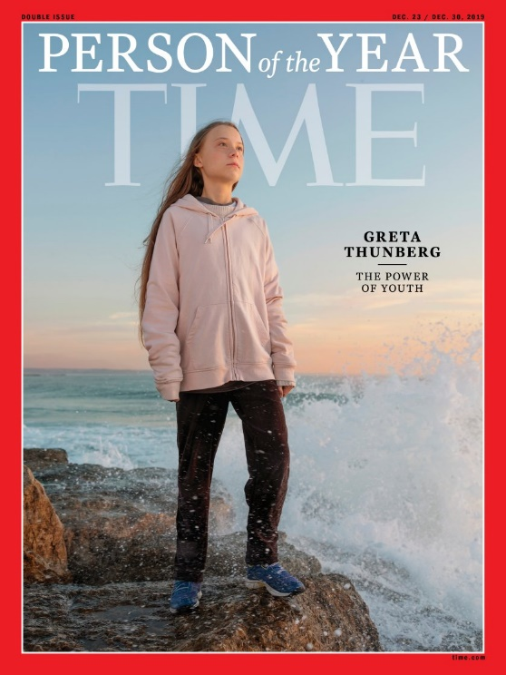

Quick Answers!
- A meat-free sausage roll.
- China.
- An Egg.
- Biggest government defeat in the House of Commons.
- Equine flu.
- The Opportunity rover on Mars.
- Refused to be substituted before penalties against Manchester City.
- Slovakia.
- The first photo of a black hole.
- Notre Dame in Paris.
- He abdicated.
- Archie Harrison Mountbatten-Windsor.
- Liverpool.
- Bran Stark, or Bran the Broken.
- Sir David Attenborough.
- Odyssey Live.
- The USA.
- Avatar.
- Jo Swinson.
- The dam above their village cracked.
- Bury.
- The prorogation of Parliament.
- Richard Madeley.
- Colleen Rooney.
- The first same-sex dancing couple (of contestants) on a TV show. (See note in the answers).
- Fortnite.
- It spun backwards for an hour. Bonus - To mark the end of British Summer Time.
- Climb Uluru / Ayres Rock.
- Prince Andrew claimed he was at Pizza Express in Woking.
- A melting block of ice.
- Andrew Neill.
- Prime Minister.
- Darts.
- Greta Thunberg.

